From Review Language to Service Frictions: Interpretable Text Mining of Low-Rating Experiences Across an Indonesian Coffee Chain
Author(s): [Insert author name(s)]
Affiliation(s): [Insert affiliation(s)]
Corresponding author: [Insert email]
General journal manuscript draft

Abstract
Online ratings compress customer experience into a single number, whereas review text can reveal the operational frictions underlying dissatisfaction. This study develops an interpretable text-mining framework for a real multi-branch coffee-chain review dataset from Medan, Indonesia. After removing three exact full-row duplicates, 1,415 reviews from 11 branches were retained. For predictive analysis, 3-star reviews were excluded to create a clearer contrast between low ratings (1–2 stars; n=284) and high ratings (4–5 stars; n=1090), yielding n=1,374. TF-IDF word features were modeled using class-balanced logistic regression with stratified five-fold cross-validation. The model achieved mean ROC-AUC=0.977 (SD=0.006), balanced accuracy=0.923, and F1 for the low-rating class=0.857. Linguistic markers associated with low ratings included lama (long/slow), tidak (not), lambat (slow), buruk (bad), pesanan (order), tidak ramah (unfriendly), menunggu (waiting), and kasir (cashier), while nyaman (comfortable), enak (delicious), ramah (friendly), and bersih (clean) characterized high ratings. In an adjusted logistic model with branch fixed effects and review length, waiting/order mentions were strongly associated with low ratings (OR=10.69, 95% CI 7.19–15.88), as were delivery-platform references (OR=2.13, 95% CI 1.10–4.11). The study shows how interpretable review mining can translate unstructured e-WOM into service-priority signals without relying on opaque sentiment scores.
Keywords: online reviews; coffee shops; text mining; interpretable machine learning; service quality; customer experience; Indonesia

1. Introduction
Online customer reviews have become a large-scale record of how service encounters are remembered, evaluated, and communicated to other consumers. In hospitality and food-service settings, review platforms simultaneously contain a compact numeric evaluation and an open-ended textual account. The star rating is convenient for benchmarking, but the review narrative contains the operational detail needed to understand why an experience was judged positively or negatively. Recent hospitality research therefore increasingly treats unstructured text as a managerial data source rather than as supplementary commentary (Bi et al., 2024; Zheng et al., 2023).
Coffee shops are particularly suitable for this type of analysis because the evaluated experience combines product quality with a sequence of service and servicescape elements: ordering, waiting, staff interaction, seating, ambience, cleanliness, access, and, increasingly, digitally mediated pickup and delivery. Tao and Kim (2022) showed that text mining can uncover coffee-shop satisfaction attributes that are not visible in aggregate ratings, while Altun et al. (2025) identified multiple experience themes in chain coffee-shop reviews. These studies support a move from “how many reviews are positive?” toward the more operationally useful question of which textual signals distinguish satisfied from dissatisfied experiences.
An important methodological problem remains. Many review studies assign sentiment labels and then report their distribution, but a sentiment score by itself does not necessarily explain what management should change. Service-quality improvement requires interpretable evidence about attributes and language associated with low evaluation. Shin et al. (2024) similarly argue for combining online review mining with interpretable machine learning so that predictive performance and managerial explanation are not treated as mutually exclusive goals. Zhang and Xu (2024) further show that unstructured review text can be used to prioritize service improvements when attributes are linked to customer satisfaction.
This issue is especially relevant for local multi-branch chains in emerging-market service contexts. A chain may have thousands of customer interactions but limited access to structured customer-research systems. Reviews offer an inexpensive continuous signal, yet Indonesian-language text is informal, frequently code-switched, and rich in colloquial negation, slang, and service-specific terms. Models that remove such linguistic information too aggressively can become less useful for diagnosing operational failure. An interpretable lexical approach can instead preserve the customer’s own vocabulary while providing reproducible evidence about low-rating signals.
The present study analyzes 1,415 usable reviews from 11 branches of a coffee chain in Medan, Indonesia. It asks three questions: RQ1, which textual features most strongly distinguish low (1–2-star) from high (4–5-star) reviews? RQ2, how accurately can a transparent TF-IDF logistic model discriminate the two rating groups out of sample? RQ3, which customer-experience aspect mentions are associated with low-rating odds after accounting for branch and review length? The study contributes methodologically by integrating predictive validation and coefficient-level interpretability, substantively by identifying service-friction language in Indonesian coffee-shop reviews, and managerially by converting review text into a prioritization tool for service recovery and process improvement.

2. Theoretical Background and Research Positioning

2.1 Online reviews as customer-experience data
Electronic word of mouth (e-WOM) differs from conventional satisfaction measurement because consumers choose what to mention, how strongly to express it, and whether to connect the evaluation to a specific service episode. This self-selected nature limits causal inference, but it also makes review text diagnostically rich. A low rating accompanied by a complaint about waiting time or staff conduct gives managers a different signal from a low rating with no explanation. Hospitality text-analysis research increasingly distinguishes prediction-oriented uses of text from understanding-oriented uses; combining both is especially useful when the goal is operational diagnosis (Bi et al., 2024).

2.2 From rating prediction to interpretable service signals
Machine-learning models can classify or predict review outcomes, but managerial usefulness depends on whether the model exposes the language and attributes associated with those outcomes. TF-IDF remains a defensible representation when interpretability is central because it downweights ubiquitous vocabulary and emphasizes terms that discriminate documents (Salton & Buckley, 1988). Logistic regression is similarly transparent: coefficient direction and magnitude indicate which textual features raise or lower the modeled probability of a low rating. More complex models may improve accuracy in some settings, but interpretable approaches are attractive when the empirical objective is to identify actionable service signals rather than to maximize benchmark performance alone (Shin et al., 2024).

2.3 Customer-experience attributes in coffee-shop reviews
Prior coffee-shop and restaurant research consistently shows that customer evaluation is multidimensional. Product quality, staff service, physical environment, location, price, and waiting processes can all enter the review narrative (Altun et al., 2025; Kim et al., 2022; Tao & Kim, 2022). However, the direction of association cannot be assumed from an attribute mention alone. For example, ambience may be mentioned because it is comfortable or because it is noisy, and product terms may occur in both praise and complaints. This study therefore combines lexical markers with aspect-level indicators and interprets aspect coefficients as associations with rating outcomes, not as causal effects of the underlying attribute.

3. Materials and Methods

3.1 Research design and setting
The study uses observational online-review data supplied by the researcher for 11 Fore Coffee branches in Medan, Indonesia. The file contains review text, a 1–5 star rating, a relative review-time string, branch name, and three pre-existing label fields. The analysis was designed as an interpretable text-mining study of rating outcomes rather than as a validation study of the supplied sentiment labels.

3.2 Data audit and cleaning
The source file contained 1,418 rows. No review text, star rating, or branch value was missing. Thirty-one observations repeated review text verbatim beyond the first occurrence, but repeated short expressions were not automatically treated as duplicates because different customers can plausibly use identical phrases. Only three observations that duplicated all supplied fields exactly were removed. The final analytical dataset therefore contained 1,415 reviews. Review length averaged 14.85 words (median=9); 270 reviews contained emojis, and no URLs were detected. The reviews were predominantly Indonesian and included colloquial forms, abbreviations, English service terms, and code-switching.

3.3 Integrity treatment of supplied sentiment labels
Two columns are explicitly named “Simulated Human 1 (10%)” and “Simulated Human 2 (5%).” They were not treated as real human annotation. The file also contains “Adjudicated Gold-Standard Labels,” but no independent annotation protocol or classifier provenance accompanies the spreadsheet. A diagnostic cross-tabulation showed that the adjudicated label was almost entirely rating-congruent: all 1–2-star reviews were Negative, all 4–5-star reviews were Positive, and only 3-star reviews varied. Using that field as an independent textual-sentiment outcome would therefore risk circular inference. For research integrity, the present paper does not report human-validation accuracy, Cohen’s kappa, or rating–sentiment agreement from these fields.

3.4 Outcome definition
To create a substantively clear binary outcome, 1–2-star reviews were defined as low ratings (n=284) and 4–5-star reviews as high ratings (n=1090). The 41 3-star reviews were excluded from the binary classification because the middle category can represent mixed or ambivalent experiences and would blur the low-versus-high contrast. The predictive sample was therefore n=1,374.

3.5 Text representation and predictive model
Review text was represented using word-level TF-IDF unigrams and bigrams. Tokens were restricted to alphabetic word forms; a modest Indonesian function-word stop list was applied, while negators such as tidak, ga, and gak were deliberately retained because they carry evaluative meaning. TF-IDF used sublinear term-frequency scaling, a minimum document frequency of three, a maximum document frequency of 0.95, and a maximum vocabulary of 12,000 features. A class-balanced logistic regression model (C=1.5) was evaluated with stratified five-fold cross-validation using a fixed random seed. Performance metrics were ROC-AUC, balanced accuracy, precision, recall, and F1 for the low-rating class. The implementation followed standard scikit-learn procedures (Pedregosa et al., 2011).

3.6 Customer-experience aspect indicators
To complement coefficient-level lexical interpretation, eight transparent aspect dictionaries were developed from recurrent terms observed in the corpus: product; service/staff; waiting/order; ambience/comfort; facilities/cleanliness; parking/access; delivery/platform; and price/value. Each review received a binary indicator for whether it mentioned a term in the corresponding dictionary. The indicators were designed as interpretable mention measures, not sentiment scores. Their prevalence in the 1,415-review dataset ranged from 4.24% for parking/access to 40.07% for service/staff.

3.7 Statistical analysis
Unadjusted associations between aspect mentions and the binary rating outcome were examined descriptively. A multivariable logistic regression then modeled the probability of a 1–2-star rating as a function of all eight aspect indicators, log review length, and branch fixed effects. Odds ratios (ORs), 95% confidence intervals, and two-sided p-values are reported. Because the data are observational and aspect mentions may themselves be consequences of satisfaction or dissatisfaction, ORs are interpreted as associations rather than causal effects.

4. Results

4.1 Dataset characteristics
Table 1. Rating distribution in the cleaned dataset
Stars | n | %
1 | 248 | 17.53
2 | 36 | 2.54
3 | 41 | 2.90
4 | 87 | 6.15
5 | 1,003 | 70.88
The rating distribution was highly concentrated at five stars (1,003; 70.88%), while 1-star reviews accounted for 17.53%. The overall mean rating was 4.103. This imbalance motivated class weighting in the predictive model and cautions against accuracy alone as an evaluation metric.

4.2 Out-of-sample discrimination
Table 2. Five-fold cross-validated predictive performance
Metric | Mean | SD
ROC-AUC | 0.977 | 0.006
Balanced accuracy | 0.923 | 0.017
F1, low-rating class | 0.857 | 0.025
Precision, low-rating class | 0.821 | —
Recall, low-rating class | 0.898 | —
The TF-IDF logistic model discriminated low from high ratings strongly across unseen folds. Mean ROC-AUC was 0.977, balanced accuracy was 0.923, and F1 for the low-rating class was 0.857. The combination of precision (0.821) and recall (0.898) indicates that the model did not achieve its performance simply by favoring the majority high-rating class.

4.3 Linguistic markers of low and high ratings
The largest positive coefficients for the low-rating class were dominated by explicit delay, negation, and service-failure language. The terms lama, lambat, pesanan, menunggu, orderan, jam, karyawan, kasir, and tidak ramah point to process and interaction failures. Informal negators ga and gak also ranked highly, showing why preserving colloquial Indonesian forms was important. In contrast, high ratings were characterized by nyaman, enak, ramah, bagus, bersih, ngopi, and nongkrong, indicating a combined evaluation of product enjoyment, staff warmth, cleanliness, and place-based comfort.
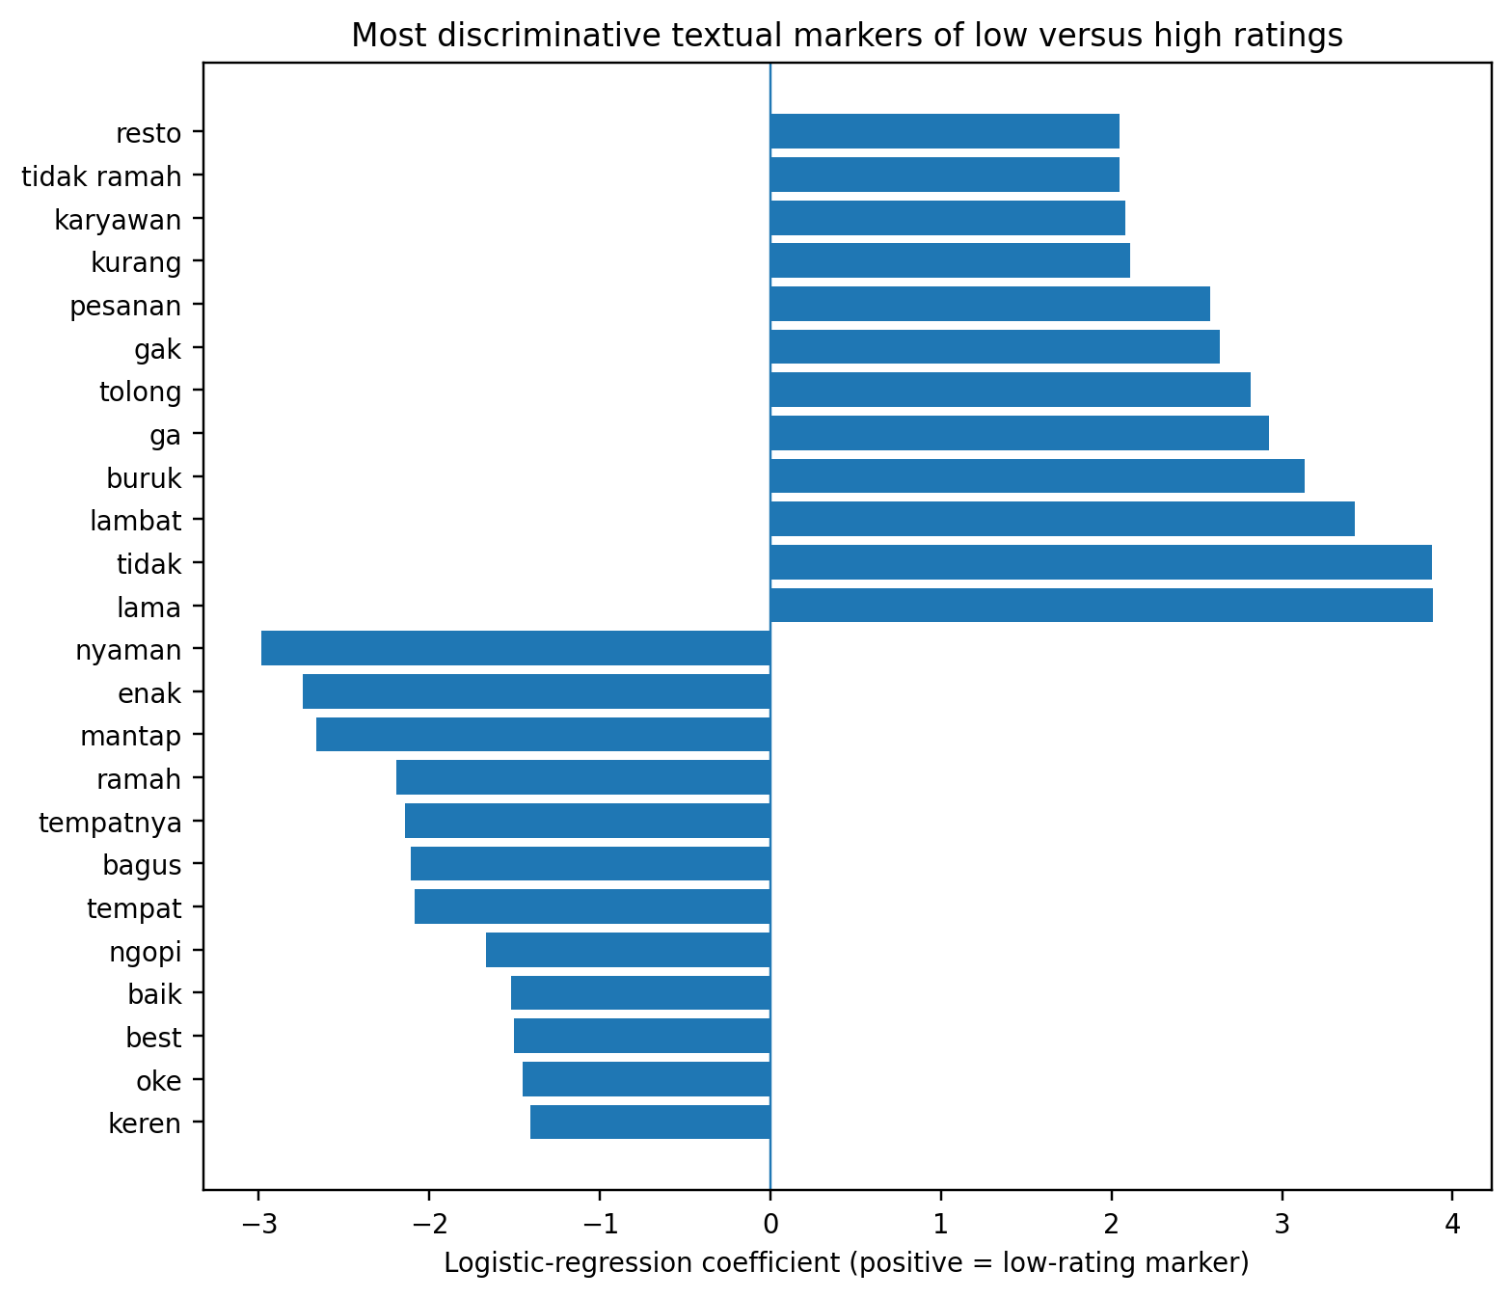
Figure 1. Most discriminative textual markers. Positive coefficients indicate stronger association with the 1–2-star class; negative coefficients indicate stronger association with the 4–5-star class.

4.4 Aspect-level associations
Table 3. Prevalence of transparent customer-experience aspect mentions
Aspect | n | % of reviews
Product | 436 | 30.81
Service/staff | 567 | 40.07
Waiting/order | 266 | 18.80
Ambience/comfort | 433 | 30.60
Facilities/cleanliness | 129 | 9.12
Parking/access | 60 | 4.24
Delivery/platform | 91 | 6.43
Price/value | 70 | 4.95
Table 4. Multivariable logistic regression for a low (1–2-star) rating
Predictor | Adjusted OR | 95% CI | p
Product mention | 0.37 | 0.24–0.56 | <0.001
Service/staff mention | 0.88 | 0.62–1.26 | 0.492
Waiting/order mention | 10.69 | 7.19–15.88 | <0.001
Ambience/comfort mention | 0.09 | 0.05–0.15 | <0.001
Facilities/cleanliness mention | 0.76 | 0.40–1.45 | 0.410
Parking/access mention | 0.44 | 0.19–1.01 | 0.052
Delivery-platform mention | 2.13 | 1.10–4.11 | 0.025
Price/value mention | 0.59 | 0.29–1.23 | 0.159
Log review length | 2.86 | 2.23–3.67 | <0.001
The adjusted model had McFadden pseudo-R²=0.361. Waiting/order mention was the dominant association: reviews mentioning this aspect had 10.69 times the adjusted odds of a low rating (95% CI 7.19–15.88). Delivery/platform mention was also positively associated with low ratings (OR=2.13, 95% CI 1.10–4.11). Longer reviews were more likely to be low rated (OR=2.86 per unit increase in log word count), which is consistent with dissatisfied reviewers providing more detailed problem narratives. Ambience/comfort mentions were associated with lower low-rating odds (OR=0.09, 95% CI 0.05–0.15), reflecting the strongly positive vocabulary with which ambience was typically discussed in this corpus. Product mention showed a similar negative association (OR=0.37, 95% CI 0.24–0.56). Service/staff, facilities/cleanliness, and price/value mention indicators were not independently significant after simultaneous adjustment.
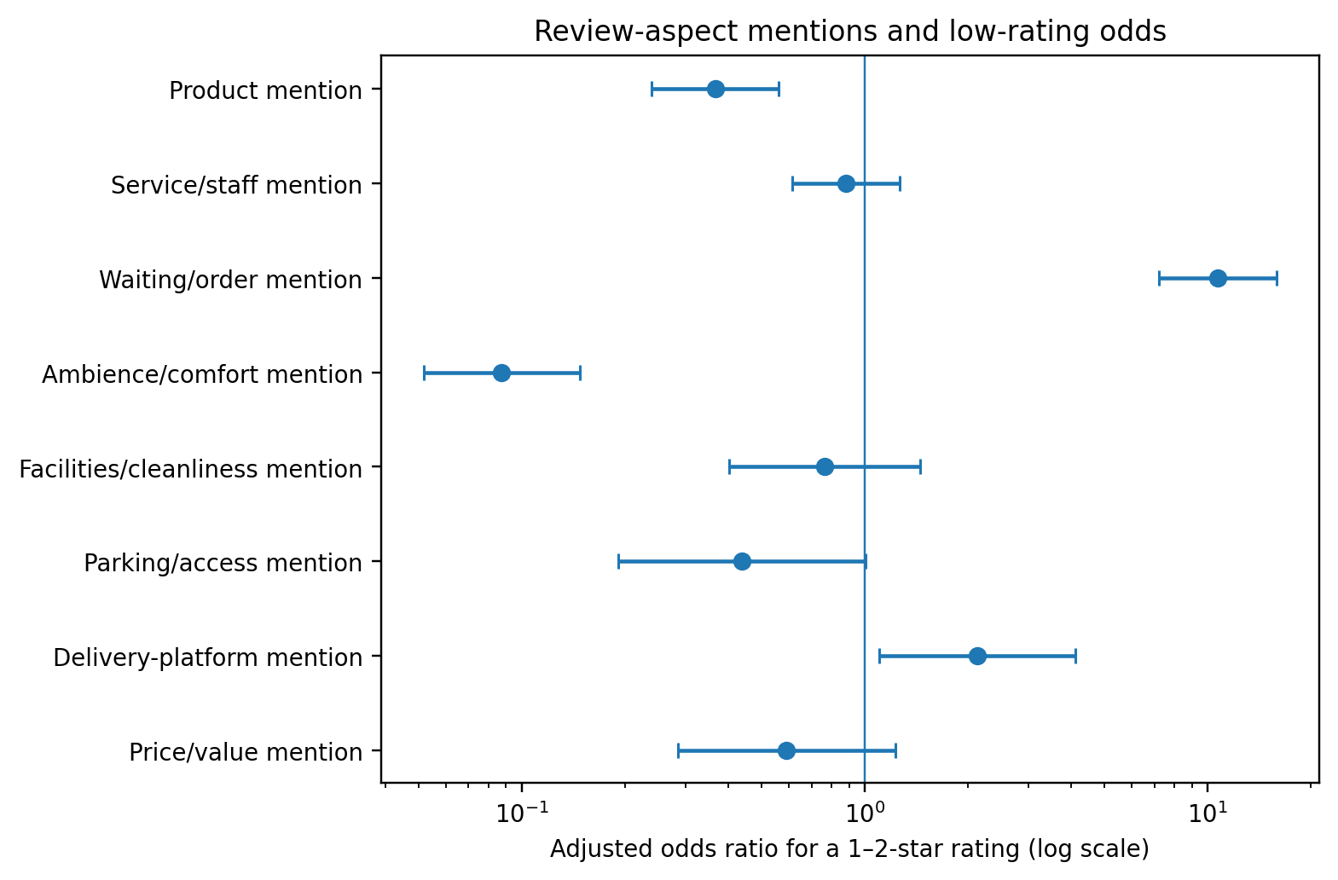
Figure 2. Adjusted odds ratios for aspect mentions. Values above 1 indicate higher odds of a 1–2-star rating; values below 1 indicate lower odds. Models also include review length and branch fixed effects.

5. Discussion
The first contribution is empirical evidence that low ratings are linguistically structured rather than diffuse. Delay-related terms and order-process vocabulary were among the strongest discriminators, and the waiting/order aspect remained the dominant association in the multivariable model. This pattern supports the idea that text analytics can reveal operational bottlenecks hidden behind an aggregate rating. In practical terms, “dissatisfaction” in this dataset is not merely a negative emotional state; it is often narrated as a temporal and process problem involving waiting, order fulfillment, and communication.
The second contribution is the combination of predictive strength and interpretability. A mean ROC-AUC of 0.977 shows that relatively simple word and phrase features carry substantial information about whether a review belongs to the low- or high-rating group. Yet the model does not require a black-box explanation layer to identify important features. This complements the logic of interpretable review mining advanced by Shin et al. (2024): when the managerial question is “what should we inspect or improve?”, transparent feature direction can be as important as predictive performance.
Third, the results show that positive experiences are also linguistically concrete. Terms related to comfort, taste, friendliness, cleanliness, and the social act of ngopi/nongkrong were characteristic of high ratings. These expressions resonate with multidimensional coffee-shop experience findings in Tao and Kim (2022) and Altun et al. (2025), but the present analysis adds a rating-discrimination perspective at the word level. The high-rating side of the model suggests that customers evaluate the coffee shop not only as a beverage outlet but also as a place for comfortable social and work-related consumption.
The delivery/platform association extends the service boundary beyond the physical shop. Even after branch and text length were controlled, explicit references to drivers, apps, delivery, or pickup processes were associated with higher low-rating odds. This result foreshadows a broader multi-actor service issue explored separately in Paper 3: a restaurant or coffee brand may receive the rating consequences of experiences that span staff, digital intermediaries, and delivery actors.
Finally, the strong association of review length with low ratings should be interpreted carefully. Longer text is not itself a service failure. Rather, dissatisfied consumers often need more words to describe sequences, exceptions, communication failures, and recovery attempts. For review-monitoring systems, this suggests that long low-rated reviews deserve priority because they are information-rich incident reports, not simply because they are negative.

6. Theoretical Implications
This study contributes to online-review and customer-experience research by linking textual micro-signals to evaluative outcomes without reducing review narratives to a single sentiment probability. It demonstrates a two-layer view of e-WOM: lexical markers reveal how customers frame an experience, while transparent aspect mentions locate that framing within service processes. The approach also distinguishes predictive explanation from causal explanation. A feature can be highly predictive of low ratings without being a manipulable cause, and an aspect mention can reflect either praise or complaint. This distinction is useful for theory because it prevents text-mining coefficients from being overinterpreted as behavioral mechanisms.
For coffee-shop research, the findings reinforce the multidimensionality of experience while highlighting waiting/order friction as a particularly diagnostic component in this corpus. The result extends prior theme-oriented work by quantifying how specific experience vocabularies discriminate low and high rating states. For service analytics, the study shows that interpretable NLP can operate as a bridge between large-scale customer voice and operational service-quality management.

7. Managerial Implications
Managers can turn the findings into a review-triage system. Reviews containing delay vocabulary such as lama, lambat, menunggu, or order-related terms should be automatically flagged for process review, especially when paired with 1–2-star ratings. The purpose is not to penalize employees on keyword counts, but to identify recurring failure patterns for root-cause analysis: queue design, drink-production capacity, handoff visibility, staffing by daypart, order-status communication, and escalation procedures.
Positive-language markers are equally useful as standards to protect. Comfort, friendliness, taste, cleanliness, and social-place vocabulary can be tracked as “experience assets.” Branch managers should investigate whether process changes that reduce waiting inadvertently weaken these valued aspects. Finally, platform/delivery references should be routed to a cross-functional review process rather than treated only as in-store complaints, because customer ratings can incorporate failures occurring at the interface between store preparation, platform information, pickup, and delivery.

8. Limitations and Future Research
The study uses one coffee brand in one Indonesian city and therefore does not claim universal service-quality weights. Reviewers are self-selected, and review text may contain sarcasm, spelling variation, or context that dictionary indicators cannot fully represent. The 1–2 versus 4–5 design intentionally excludes 3-star reviews and should be interpreted as a contrast model rather than a full five-class rating model. Aspect indicators measure whether an aspect is mentioned, not whether it is praised or criticized. Future work should validate aspect sentiment manually on a genuine human-annotated sample, compare transparent TF-IDF models with Indonesian transformer models, and test whether the same delay and service markers replicate across brands and cities.
A further limitation concerns the supplied label fields. Two are explicitly simulated, and the adjudicated label is almost perfectly aligned with star categories; none can support a defensible claim of independent human validation. Future research should build a prospectively annotated gold standard with at least two trained human raters, adjudication rules, class definitions, and inter-rater reliability before evaluating any sentiment classifier.

9. Conclusion
Using 1,415 cleaned reviews from 11 coffee-shop branches, this study shows that customer dissatisfaction can be detected and interpreted from the language of online reviews. A transparent TF-IDF logistic model strongly discriminated 1–2-star from 4–5-star reviews (mean ROC-AUC=0.977), while coefficient inspection identified delay, ordering, and service-failure vocabulary as prominent low-rating signals. At the aspect level, waiting/order references showed the largest adjusted association with low ratings (OR=10.69), and delivery-platform references also remained significant (OR=2.13). The practical contribution is a reproducible route from unstructured e-WOM to service-priority signals: instead of treating sentiment as an endpoint, managers can use interpretable text analytics to locate recurring frictions and protect the experience attributes that customers explicitly value.

Declarations
Funding: [Insert funding information, or state that the research received no specific grant if accurate.]
Conflict of interest: The authors declare no conflict of interest, subject to confirmation by all authors before submission.
Data availability: The cleaned analytical dataset may be shared by the corresponding author subject to the original data-source terms and any platform restrictions. A de-identified derived feature table and analysis code are recommended for reproducibility.
Ethics statement: The study analyzes publicly posted online review text supplied as a research dataset. Direct personal identifiers were not used in the analyses reported here. The authors should confirm the originating platform’s terms of use and the applicable institutional ethics requirements before submission.
Author contributions: [Insert CRediT roles after the final author list is confirmed.]
Acknowledgments: [Insert acknowledgments if applicable.]

References
Altun, Ö., Saydam, M. B., & Gunay, T. (2025). Unraveling customer experiences in chain coffee shops through online reviews. British Food Journal, 127(6), 1895–1909. https://doi.org/10.1108/BFJ-11-2024-1160
Bi, J.-W., Zhu, X.-E., & Han, T.-Y. (2024). Text analysis in tourism and hospitality: A comprehensive review. Journal of Travel Research, 63(8), 1847–1869. https://doi.org/10.1177/00472875241247318
Kim, J., Lee, M., Kwon, W., Park, H., & Back, K. J. (2022). Why am I satisfied? See my reviews – Price and location matter in the restaurant industry. International Journal of Hospitality Management, 101, 103111. https://doi.org/10.1016/j.ijhm.2021.103111
Park, J. (2023). Combined text-mining/DEA method for measuring level of customer satisfaction from online reviews. Expert Systems with Applications, 232, 120767. https://doi.org/10.1016/j.eswa.2023.120767
Shin, J., Joung, J., & Lim, C. (2024). Determining directions of service quality management using online review mining with interpretable machine learning. International Journal of Hospitality Management, 118, 103684. https://doi.org/10.1016/j.ijhm.2023.103684
Tao, S., & Kim, H.-S. (2022). Online customer reviews: Insights from the coffee shops industry and the moderating effect of business types. Tourism Review, 77(5), 1349–1364. https://doi.org/10.1108/TR-12-2021-0539
Zhang, C., & Xu, Z. (2024). Gaining insights for service improvement through unstructured text from online reviews. Journal of Retailing and Consumer Services, 80, 103898. https://doi.org/10.1016/j.jretconser.2024.103898
Zheng, X., Huang, J., Wu, J., Sun, S., & Wang, S. (2023). Emerging trends in online reviews research in hospitality and tourism: A scientometric update (2000–2020). Tourism Management Perspectives, 47, 101105. https://doi.org/10.1016/j.tmp.2023.101105
Pedregosa, F., Varoquaux, G., Gramfort, A., Michel, V., Thirion, B., Grisel, O., Blondel, M., Prettenhofer, P., Weiss, R., Dubourg, V., Vanderplas, J., Passos, A., Cournapeau, D., Brucher, M., Perrot, M., & Duchesnay, É. (2011). Scikit-learn: Machine learning in Python. Journal of Machine Learning Research, 12, 2825–2830.
Salton, G., & Buckley, C. (1988). Term-weighting approaches in automatic text retrieval. Information Processing & Management, 24(5), 513–523. https://doi.org/10.1016/0306-4573(88)90021-0

